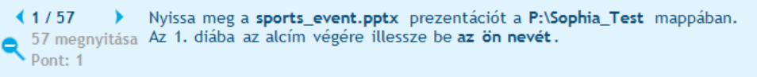



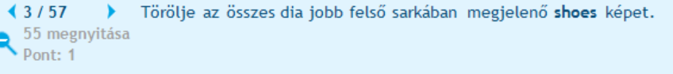

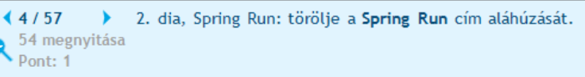



áthelyezés után kisebb lett a betűméret!!!





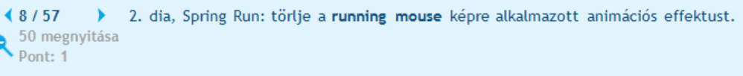





Térközre gondolt?





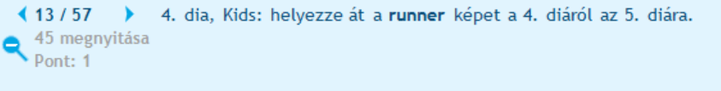

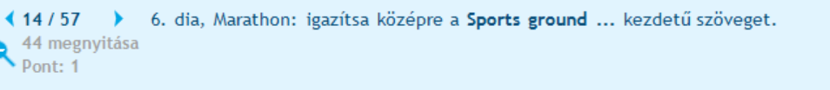





rectangle = téglalap



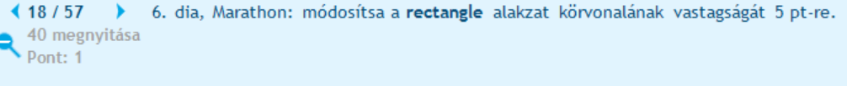

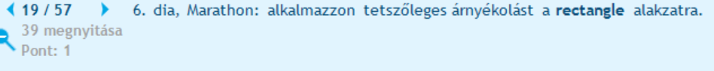

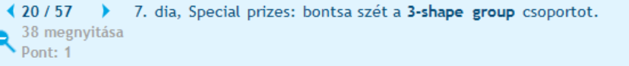



A formátumát is módosítani kell!



Nem növelje?



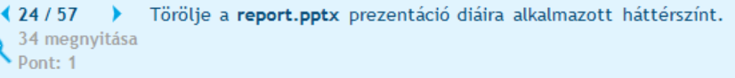

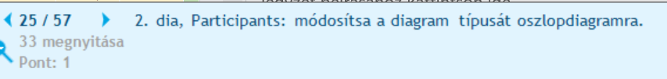

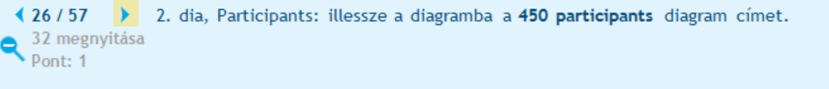

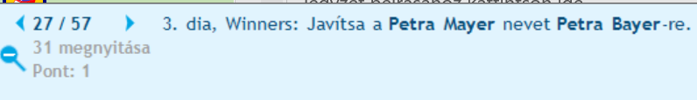

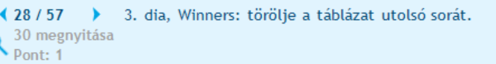

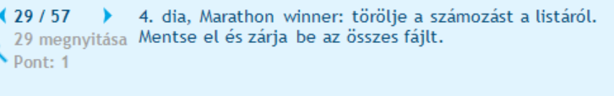



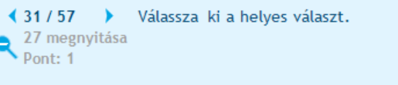

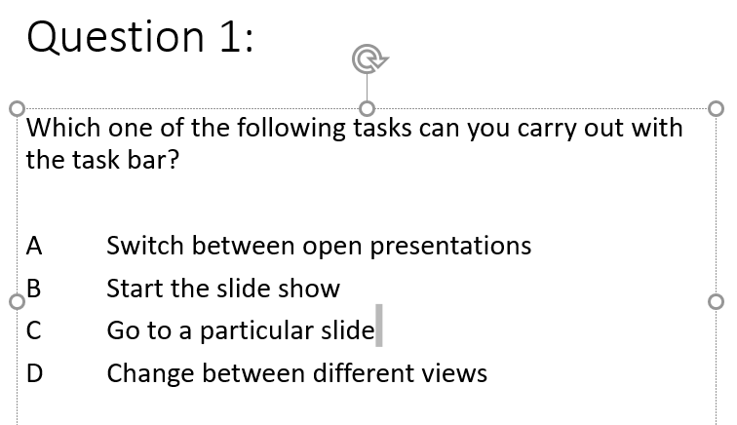

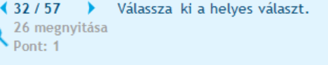

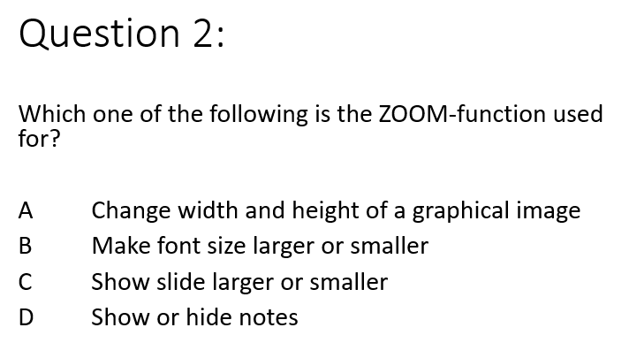

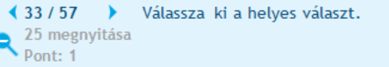

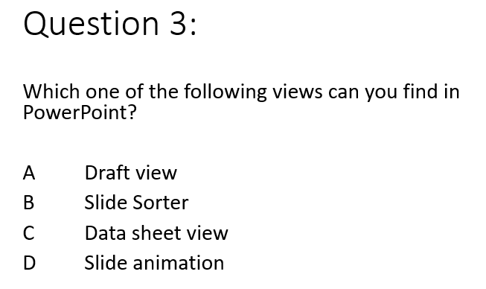

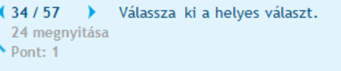

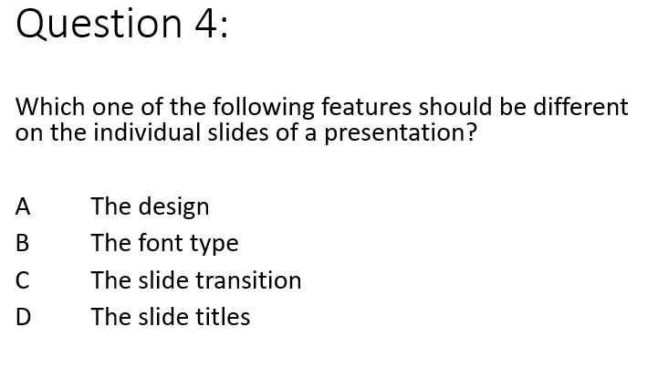

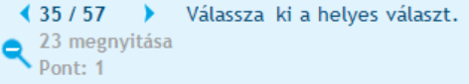

Which one of the following guidelines reflects good practice for text on slides?

A Use continuous text with complete sentences

B Use concise lists

C Apply different colour format to each line

D Give information in great detail

The letter of the correct answer (A, B, C or D) is:

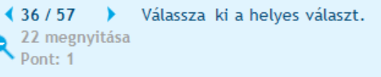

Which one of the following do you print for the audience?

A Notes pages

B Outline

C Hand-outs

D Presentation pages

The letter of the correct answer (A, B, C or D) is:

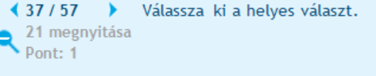

Which one of the following keys is used to start the online help of PowerPoint?

A F1

B F5

C Shift+F6

D Shift+0

The letter of the correct answer (A, B, C or D) is:













